Tiny 1 (T1) User and Developer's Guide
Rev. 3.3 01/31/11
Revisions

rev. | date | by | changed
2.0 | 12/4/06 | SPJ | Initial
3.0 | 1/9/11 | SPJ | Major update. Explains all commands. Improved guide to scripts
3.1 | 1/14/11 | SPJ | Fills out explanation of expression. Adds 'Script File Formats' section.
3.2 | 1/30/11 | SPJ | Current per script.c rev 1.4. better '$', '$$' printout control. Conditional pause.
3.3

Table of Contents
1: Classes 2
2: Editing at the terminal 3
3: (User) Commands 3
3.1:Summary 3
3.2:Command reference 4
4: Expressions (Eval or <) 10
4.1:Number Literals 10
4.2:Binary Operators 11
4.3:Assignment 11
4.4:Unary Operators 11
4.5:Vectors 12
5: Scripts 12
5.1:Loading Scripts 12
5.2:Script Format 12
5.3:Running scripts 13
5.4:Reserved Words 13
5.5:User commands in scripts 13
5.6:Conditions and fail flags 14
5.7:Timing script actions 14
5.8:Independently timed actions 15
5.9:Subroutines 15
5.10:Script command listing 16
6: Script File Format 20
Introduction
This manual describes Tiny1, the operating system which runs the IBench testers. First, because I will be asked... why is it called Tiny1? The name comes from the core scheduler/RTOS which runs e.g Sequel. This was a stripped down version of the IBench scheduler, and is sized to run in systems in the 64K/4K range. Hence 'Tiny'. (There's also a 'Nano' 16K/2K systems).
This name was later used to cover object / text UI system which runs in the testers and the Sequel Simulator. More basically though, this system grew over time; when you first choose a name you don't know where things will end.

Classes
The Tiny1 system has classes for testgear. Some of these derive from the IBench and have the same behaviour as their IBench namesakes. Others were added with the needs of testgear in mind.
Right now the classes are just listed. I'll fill out the behaviours later. In the meantime go to the command reference. Each class has a command to talk to objects of that class. You can see the behaviour there.

Threads
These are internal software processes, Read status, stopped etc.

Lists
Lists of obejcts

Scalar
A single integer, can be read or written

Vector
A vector, can be read or written

Cal (calibrations)
A single cal number (integer), Can be read, written, stored in Flash, reset to default

CalV (calibration vectors)
Same as Cal but a vector

Sensors
Scaled to standard units, can be read

Actuators
Scaled to standard units, can be read, written, reset

InPin
Input line, 1 or 0

Outpins
An actuator which can be 1 or 0

Outports
An array of up to 16 outpins, which can be written or read as a group.

Timers
These are used internally by scripts to genrate asynchronous actions.

Servo
A proportional-integral servo. Each servo can be programmed with a Sensor (to read), an Actuator (to drive), set-points for input and output and proportional and integral gain terms.

Editing at the terminal
Commands are entered via a line editor which works with an ANSI terminal. The editor is full-duplex (echoes what's typed).
<Enter> completes a line
<BkSpc> deletes before the cursor
<Del> deletes at the cursor.
<left-arrow / right-arrow> moves the cursor
<Ctrl-Z> cursor to line start
<Ctrl-X> cursor to line end
<Ctrl-A> clear whole line
<Ctrl-E> clear to end of line
<Ctrl-I> Toggle insert / overwrite (default is insert)
The editor stores the 5 most recent lines
<Up arrow>, <down arrow> select the next and previous stored lines
Once <Enter> is pressed the command line is processed. A command may have arguments, each separated by one or more spaces. The command and its args are entered as one line, with CR or CRLF to finish.
Equipment may not have all commands installed. To see whats a particular device has type 'help'. The help text usually describes the command format.

(User) Commands
Each T1 class has a command to control / read it. There are system-level commands not specific to any class. These together are the User Commands, as they can be send from the terminal at any time. There are also Script Commands, which provide control inside scripts and are only recognised when encountered in a executing script. See sec.5 Scripts for information on these.
User commands returns and scripts
Any user command can be used in a script and will have the same effect there as when entered at the terminal. Each user command returns success (1) or fail (0). The result controls the lastFailed and anyFailed flags in the script engine. These flags allow scripts to branch on the results from user commands. See 5.6 Conditions and fail flags in the scripts section.
Most user commands return 1 = success, unless they are missing arguments or their argument is a non-existent object. Only eval (evaluates expressions) and compare (compare variables against limits) would usually be used to control to flow of script execution.

Summary

System / General
echo - Full / half duplex; the default is full
help / ? - Help on any command or object. or a list of all installed commands
quiet - Silences debug printfs
objs - List all objects
read - Reads any readable object
write - Writes any writable object

Class-specific
sensor - may be read
thread - Monitors and controls thread, if they are listed as objects
actuator - may be written or read; and have a default value
outPin - an actuator which can be written 1 or 0
outPort - an array of up to 16 outPins, read or written as a group.
inPin - input line reads 1 or zero
txtfile - holds scripts
script - run scripts
cal - scalar calibrations. Can be stored, have a default,
calv - vector calibrations
eval - Evaluates and expression – See expressions
svc - Service mode control
compare - compares scalars or vector against limits
servo - proportional/integral (PI) servo

Command reference
Syntax for command formats:
(ss) = alternative text for a command e.g (?) is the same as 'help'
< nn > = required argument;
[ nn ] = optional argument
[ nn ]... or < nn >... = one or more repeats
a | b | c = alternatives, a OR b OR c
'raw' = string literal
echo <'on' | 'off' | string to echo>
Character echo on/off. The power up default is echo on. This is the setting you will normally want as you are using the system's built-in line editior.
help (?) <command or object name>
Prints built in help on any command or object.
quiet <1|on |0|off>
Blocks debug printouts. Default is printouts enabled. There are usually not many of these, so leave it alone.
objs
This lists all system objects, grouped by class. Use this command when you can't remeber the exact name or spelling of an object
read <readable scalar or vector>... ['raw' ] | ['numsOnly']
This reads and prints one or more readable scalars or vectors. By default it prepends each value with a name and appends each with units, if the variable has units.
> read Pres6
: Pres6 = 100.5 kPa
> read v1 Pres6
: v1 = 0.00 Vdc Pres6 = 100.5 kPa
> read CellTmprs
: CellTmprs = 22.3 22.5 21.6 22.7 22.0 23.1 degC
Appending 'raw' prints the unscaled integer representation of the variable
> read Pres6 raw
: Pres6 = 10052
'numsOnly' omits the units and the name. This is useful for printouts to be pasted into Excel, especially as part of a repeated read in a script. The following line take 5 temperature readings 5 secs apart.
> repeatIntvl 5 5.0 : read CellTmprs numsOnly
: 22.3 22.5 21.6 22.7 22.0 23.1
22.4 22.5 21.2 22.7 22.1 23.3
22.2 22.4 21.5 22.8 21.9 23.0
22.6 22.4 21.3 22.8 22.2 23.2
22.1 22.3 21.5 22.6 22.3 23.2
Both these args give the raw number(s), unnamed.
> read Pres6 v1 raw numsOnly
: 10052 0
write <writable scalar or vector> <num>... ['raw']
This writes values to a writable scalar or vector.
> write v1 8.4
> read v1 : v1 = 8.40 Vdc
If 'raw' is appended then 'num' is read as the unscaled internal representation of the variable.
write v1 2300 raw
> read v1 : v1 = 2.30 Vdc
If 'num' is outside the boundaries of the internal integer representation then it will be clipped.
write v1 120.6
> read v1 : v1 = 32.77 Vdc
> read v1 raw : v1 = 32767
sensor <sensor name> <action = ('read' ['src'] | 'report') ['raw'] >
Reads a Sensor in various formats. Also dumps the sensor gain and offset settings.
sensor Pres6 read - pressure sensor 'Pres1' in kPa
.. .. read src - returns raw input to sensor
.. .. read raw - pressure sensor 'Pres1' in internal units
.. .. report - shows gain, offset and status flags
Examples:
sensor Pres6 read : Pres6 = 100.5 kPa
> sensor Pres6 read raw : Pres6 = 10055
> sensor Pres6 read src : 3416
> sensor Pres6 report
: Pres6 = 100.6 kPa raw = 10058 src = 3416 flags = 0
Config: offset = -1055 numerator = 1186 denominator = Pres6Gain = 0.045 V/kPa flags = 2
Note that a sensor can also be read with 'read' (it's a readable scalar)
thread <thread_name> ['run' | 'stop' | 'restart' | 'report'
To control system threads, if your application has them listed as objects. Normally you don't mess with threads. For engineering really.
actuator <actuator name>
<action = 'read' ['raw'] | 'write' value ['raw']| 'reset' | 'lock' | 'free' |'report' >
Controls Actuators, such as pumps and valves. Summary
actuator pumpV read - prints current value e.g 2.8V
.. .. .. read raw - prints raw value 2800
.. .. .. write 3.3 - pumpV <- 3.3V
.. .. .. write 3300 raw - pumpV <- 3.3V
.. .. reset - resets to default
.. .. lock - blocks application from writing pumpV
.. .. free - undoes lock
.. .. report - current value, limits and lock status
For example, a pump drive duty cycle:
> actuator Pump1Drv0 read : 5.0 %
> actuator Pump1Drv0 write 7
> actuator Pump1Drv0 read : 7.0 %
> actuator Pump1Drv0 read raw : 700
> actuator Pump1Drv0 report
: value = 7.0 locked = 0 limits: 2.0 40.0 %
> actuator Pump1Drv0 lock
> actuator Pump1Drv0 report
: value = 7.0 locked = 1 limits: 2.0 40.0 %
If a value written to an Actuator exceeds the Actuator limits then the value will be clipped
> actuator Pump1Drv0 write 60
> actuator Pump1Drv0 read : 40.0 %
'reset' returns the Actiator to it's preset default value
> actuator Pump1Drv0 reset
> actuator Pump1Drv0 read : 5.0 %
Note that Actuators can be controlled with read and write commands.
> write Pump1Drv0 25
> read Pump1Drv0 : Pump1Drv0 = 25.0 %
outPin <pin name>
<action = 'read' | ('write' '0'|'1'|'on'|'off'|'set'|'clear' ) | 'reset' | 'lock' | 'free' | 'report' >
Controls OutPins i.e single digtial outputs. These are like Actuators except that they are only1 and 0 (on and off). For e.g valves.
outPin valve3 read - print current setting of valve3
outPin valve3 write on - valve3 <- on
.. .. write 1 - same as 'on'
.. .. reset - puts valve3 into reset state
.. .. lock - so application can't write valve3
.. .. free - undoes lock
.. .. report - current setting and lock status
Examples:
> outPin Led1 read : 0
> outPin Led1 report : value = 0 locked = 0
> outPin Led1 write on
> outPin Led1 read : 1
> outPin Led1 lock
> outPin Led1 report : value = 1 locked = 1
inPin <pin name> <action = 'read'>
InPins are digital inputs. They are just read. Note that the 'read' command does the same.
> inPin Sw1 read : 1
> read Sw1 : Sw1 = 1

outPort <port name> <action = 'read' | 'write' <val | 'off'> | 'reset' | 'lock' | 'free' | 'report' >
A group of individual pins can be consolidated as an OutPort and accessed all together with a single command. The options are the same as for outPin except that read and write parms can be a (hex) number which controls multiple inputs and outputs.

compare <n1 = scalar or vector>
<comparision = 'greater''>' | 'less''<' | 'inside' |'equal''==' | 'notEqual' '!=' '<>'>...
<n2 = limit | lo limit> [n3 = hi limit] ['raw']
Compares Scalars or Vectors against limit(s). If the compare condition is not true then prints an error message.
Returns: 1 if the condition was true, else 0.
'n1' may be (the name of) a Scalar or Vector. 'n2', 'n3' may be Scalar, Vectors or literal numbers. How 'n2' and 'n3' are read depends on the type of variable and type of comparsion.
If 'n1' is a Scalar then 'n2', 'n3' must be either Scalars or literal numbers. If the comparsion argument is 'inside' then both arguments are required, else just n2 is needed. If 'raw' is appended to the command the literals are taken to be internal numbers, otherwise literals are scaled before being compared to the internal, integer, value of the Scalar. Examples:
> read v1 : v1 = 5.00 Vdc
> compare v1 > 3 ; true, so no message printed
> compare v1 > 7 : v1: under limit val = 5.00 Vdc min = 7.00
> compare v1 inside 7 10.3
: v1: outside limits val = 5.00 Vdc min = 7.00 max = 10.30
> read v1 v2 v3
: v1 = 5.20 Vdc v2 = 3.30 Vdc v3 = 6.40 Vdc > compare v2 inside v1 v3
: v2: outside limits val = 3.30 Vdc min = 5.20 max = 6.40
If 'n1' is a Vector then n2 may be a Vector OR 'n2', 'n3' may be literals. If 'n2' is a Vector then how it is read depends on the type of comparison. If 'greater' or 'less' then 'n2' compared, element by element against 'n1'. If 'inside' then 'n2' is read as a series of number-pairs, each pair being a lower limit followed by an upper limit.
> read O2Cells
: O2Cells = 6.55 4.20 2.30 0.69 1.80 6.88 mV
> compare O2Cells > 5.0
: O2Cells[1]: under limit val = 4.20 mV min = 5.00
O2Cells[2]: under limit val = 2.30 mV min = 5.00
O2Cells[3]: under limit val = 0.69 mV min = 5.00
O2Cells[4]: under limit val = 1.80 mV min = 5.00
> compare O2Cells inside 5.0 10.0
: O2Cells[1]: outside limits val = 0.00 mV min = 5.00 max = 10.0
O2Cells[2]: outside limits val = 2.30 mV min = 5.00 max = 10.0
O2Cells[3]: outside limits val = 0.69 mV min = 5.00 max = 10.0
O2Cells[4]: outside limits val = 1.80 mV min = 5.00 max = 10.0
cal <calibration name>
<action = 'read' | 'write' value_to_write | 'store' | 'recall' | 'dflt' | 'report' > ['raw']
Controls Calibrations. Like the IBench, these have current, stored and default values. For example, 'Ox1Gain' is the amplifier gain tweak in the O2 tester.
cal Ox1Gain read - print value of 'n1' with units
cal Ox1Gain read raw - print raw value
.. .. write 3.85 - set to 3.85 (scaled)
.. .. write 3850 raw - same as above but write raw value
.. .. default - reset current value to default
.. .. store - copy current value to NV store
.. .. recall - copy NV value to current
.. .. report - show all data on 'Ox1Gain'
Examples:
cal Ox1Gain report
: Ox1Gain: hdl = 21 val = 2300 stored = none min = 2231 max = 2369 dflt = 2300
> cal Ox1Gain write 2340
> cal Ox1Gain store
> cal Ox1Gain report
: Ox1Gain: hdl = 21 val = 2339 stored = 2339 min = 2231 max = 2369 dflt = 2300
calv <cal_vector_name>
<action = 'read' | 'write' index value | 'store' | 'recall' | 'dflt' | 'report' > ['raw']
This handles a vector of multiple Calibrations. They are written individually but other operations act on the whole group.
eval <unary, binary or ternary expression>
Evaluates and prints the value of an expression. See sec.4 Expressions (below).

servo <servo name> <action = (
'make' <sensor name> <actuator name> [input set point] [output set point] [proportional gain] [integral gain]
| 'run' | 'stop'
| 'inPoint' <input set point>
| 'outPoint' <output set point>
| 'pgain' <proportional gain>
| 'igain' <integral gain>
| 'report'
| 'showRun'
This command specifies and controls 'servo' objects (see Servo class above).
In the 'make' subcommand, the 1st 2 args are required. One or more of the other parms may be supplied (in order). Any parms not supplied default to zero. Giving all of the parms in 'make' completely specifies the servo. They can also be added or changed individually using the 'inPoint' 'outPoint', 'pgain' and 'igain' subcommands.
'run' starts the servo; 'stop' suspends it. The servo set-points and gains may be changed while the servo is running.
'report' shows all the servo settings; it also display the current sensor reading and actuator settings.
'showRun' enables a runtime printout of the servo activity. The printout shows the sensor and actuator values plus the error accumulator. This helps a user tune up a servo. The printout is canceled when a 'stop' is sent.
Examples; make an empty servo:
> servo servo1 make Pres6 Pump1Duty0
> servo servo1 report
: sensor = Pres6 actuator = Pump1Duty0
inSetPt = 0.0 kPa outSetPt = 0.0 % pGain = 0.0 iGain = 0.0 kPa/%
running = 0 Pres6 = 99.5 kPa Pump1Drv0 = 5.0 %
Note that 'report shows the current reading from the Sensor and the current setting of the Actuator. Now make a complete servo:
servo servo1 make Pres6 Pump1Duty0 90 4.8 2 1.6
> servo servo1 report : sensor = Pres6 actuator = Pump1Duty0
inSetPt = 90.0 kPa outSetPt = 4.8 % pGain = 2.0 iGain = 1.6 kPa/%
running = 0 Pres6 = 99.5 kPa Pump1Drv0 = 5.0 %
Enable the pump power supply and run the servo. The debug report (every 3 secs) shows the internal integers of the servo in action.
> write Pump1Vdrv 6.0 ; Set pump power to 6V.
> servo servo1 run
Servo: sens 8990 act 280 set 9000 pGain 40 iGain 10
ofs 480 err -10 acc -3612 min/max 18999
Servo: sens 8995 act 279 set 9000 pGain 40 iGain 10
ofs 480 err -5 acc -3823 min/max 18999
How to set up a (pneumatic) servo
- On the O2 tester, a servo controls the pump (the Actuator) in response to a pressure or flow read from a Sensor. There can be different servo settings optimised for each pneumatic condition.
- Set up or check the control range for the pump.
The main pump in the O2 tester has a PWM drive. There's also a bleed to add flow to the pump if it needs that. Set up the valves etc as they will be under the servo. Find the combination of voltage (Pump1Vdrv) and base PWM (Pump1Duty0) at which the pump has a reasonable control characteristic. Do this by write-ing the pump and observing the resulting pressure and flow. Record the Sensor and Actuator settings at the desired set-point.
- Using these Sensor and Actuator settings, make the servo <servo servo1 make ....'>. Start with a low 'pgain' setting e.g 1.0 and with igain = 0.
- Enable run-time printouts <servo servo1 showRun> and run the servo <servo servo1 run>. Check that it nails the set point with a fairly small proportional error.
- Try increasing the proportional gain <servo servo1 pgain 'nnn'>. If you go too high the servo will become unstable. Then back off at least x2 - x4 for a stability margin.
- Try adding some integral gain <servo servo1 igain 'nnn'>. This should reduce variations in the set-point over time. Again, if you go too far the servo will wing-wang. Back off.
- If the 'igain' setting is much lower than the 'pgain' then the servo is probably running too fast. Reduce the run rate using 'runIntvl' until the two numbers are about equal.
- Remember the settings. they will go in the servo control script.
txtfile 'report' | <fileNum <<'write' ['term']>|'clear'|'list'>>
Handles text stores in Flash. There are a fixed number of these; the number and size of each depends on the application. They are usually used to hold scripts.
txtfile 1 report - shows numbers, size and contents of all files
.. write - to stream a text file from terminal
.. write term - to type text in line by line
.. clear - erases fileNum'
.. list - prints contents of 'fileNum'
Examples, from the O2 tester.
'report' shows each file and how many bytes it contains If the file has some test it shows the 1st line. So with scripts it's useful to quote the script name and version on the 1st line.
> txtfile report
: Bank 0 start 8000 size 2048 contains 0
Bank 1 start 8800 size 2048 contains 70
---- $ O2 Gain linearity ver1 12/2/10
Bank 2 start 9000 size 4096 contains 0 Bank 3 start a000 size 4096 contains 0 Bank 4 start b000 size 4096 contains 0 Bank 5 start c000 size 8192 contains 0 Bank 6 start e000 size 8192 contains 0
> txtfile 1 list
:$ Flash Led1 10 times
repeat 10 Led1 = 1
wait 1
Led1 = 0 wait 1 endrepeat $ done
To stream text from a file via the terminal first set the inter-char send interval to at least 1msec. Then select the file to be sent. Make sure it will fit in the store.
> txtfile 2 write : Send ASCII now, > 1msec inter-char interval; Esc to quit
Send the file, then hit <esc> once its sent. The terminal will print the file contents:
Echo to check:
:$ Flash Led1 10 times
repeat 10 Led1 = 1
wait 1 ..... etc
There's no need to erase existing text from a store before sending a new text file.
script <script_number> <'run' | 'write' | 'list'>
To load and run scripts. See sec.5 Scripts (below) for details on this command

Expressions (Eval or <)
T1 supports unary, binary and ternary expressions. They can be evaluated on the command line using 'eval' or they can by conditional expressions in scripts. Some quick Examples:
On the command line
eval SupplyV = 12.4V (does the same as read)
eval SupplyV > 10 = 1 (true)
eval Pres1 = 90kPa
eval Pres1 + 10 = 100kPa
eval Pump1Drv = 6.2 = 6.2V (Pump1Drv is now 6.2V)
eval v1 = 1V (if scalar v1 if defined as scaled to volts)
eval Pump1Drv = v1 + 1 = 7.2V (Pump1Drv is now 7.2V)
eval Pump1Drv raw = 7200
eval Pump1Drv = 3000 raw = 3000 (the internal representation for 3V)
In scripts:
quit Pres6 > 100 ; will quit if Pres6 > 100kPa
while Sw1 == 0 ; loop until Sw1 pressed

Number Literals
Literal numbers in expressions may be decimal integers, decimal floating point, hexadecimal (0xnnn) or binary (0bnnn). Floating point numbers are rounded down to their internal integer representations Binary numbers may be diced up by underscores in any position. Examples:
> eval 348 : 348
> eval 25.23 : 25
> eval -1.24E3 :-1240
> eval 0xBAD : 2989
> eval 0b1100_0011 : 195
If an expression contains a scaled variable e.g sensor Pres6 in kPa, then literal numbers are read in the units of the variable e.g
> eval Pres6 : 99.9 kPa
> eval Pres6 > 100.4 : 0
> eval Pres6 - 50 : 49.9 kPa
If 'raw' is appended to an expression and that expression contains a variable then any literal is read as the internal integer representation of the variable.
> eval Pres6 raw : 9992
> eval Pres6 > 100 : 0
> eval Pres6 > 100 raw : 1
Arguments are converted to integers before being used in expressions as this is how signal processing happens in most tester apps. e.g
eval 3 + 4 = 7 and eval 3.7 + 4.6 = 7

Binary Operators
T1 supports all the usual 'C'-style operators. Operators and precedence are:
assignment > comparision > arithmetic and logical i.e
[=, +=, -=, *=] (assignment (with add / subtract / multiply)) >
[ >, <, >=, <=, == (Equal), != (not equal) ] >
[+ - *(multiply) \ (divide) && (and) || (or) ]
Within each class evaluation is from left to right ie
> eval 10 + 4 / 2 : 7
In logical operations any non-zero number is '1' = TRUE.
> eval Led1 : 1
> eval Led1 && 0 : 0 ; 0 is FALSE
> eval Led1 && 43 : 1 ; 43 is TRUE

Assignment
The l-value for of an assignment must be a writable object. Trying to assign to a non-writable object returns 'fail' = 0;
> eval Led1 = 1 : 1 ; Light Led1
> eval Pres6 = 30 : 0.0 kPa ; Illegal operation, returns 0
( Illegal operations return 0. They should print error messages too; but right now only a few do.)

Unary Operators
T1 supports '-' (minus) and '!' (not). These may be prepended to any variable.
> eval -Pres6 : -99.9 kPa
> eval Led1 : 0
> eval !Led1 : 1
> eval !Pres6 : 0 ; Not of any non-zero value is 0
> eval Pres6 && !Led1 : 1 ; Can combine logical and numeric

Vectors
T1 has operations which return a Scalar result from a Vector. The syntax is < vector_name.suffix > where 'suffix' is an operation. The operations are 'min', 'max' 'mean' = 'avg'.
Vectors elements can be access by an index, again using the 'dot' notation. INdices are 'C'-style; the 1st element is index 0 (zero).

read O2Cells : O2Cells = 6.47 1.10 0.00 0.69 0.00 6.80 mV
> eval O2Cells.1 : 1.13 mV ;
> eval -O2Cells.1 : -1.13 mV ;
> eval O2Cells.max : 6.78 mV
> eval O2Cells.mean : 2.50 mV
> eval O2Cells.avg > 3.2 : 0
> eval O2Cells.min - O2Cells.max : -6.80 mV

Scripts
The T1 system can be built to run scripts. At their simplest these are lists of commands, as they would be sent from the terminal. They are stored in text file areas and are run from there. This allows T1 systems to be programmed with complex behaviour and run this behaviour standalone.

Loading Scripts
Scripts are held in text stores (files) in Flash. There are usually 2 or 8 of these, from 512 bytes or 8K each. The files are numbered 0,1... At present each will hold one script, which is labeled with the same number as the file.
Scripts can written as text files on a PC and streamed into Flash from a terminal. There are two ways of doing this. The first is to send using the 'txtfile' command. This enters the text into Flash verbatim.
> txtfile 1 write <Enter>
: 'Send text now, 1msec inter-char interval; Esc to quit'
Now start the file send from terminal. The text will be written to Flash as it is streamed from the terminal. You can interrupt this by pressing 'Esc'. Otherwise T1 will finish up about 2 secs after the last char is sent.
The other option is to use the 'script' version of the same command.
> script 1 write <Enter>
: 'Send text now, 1msec inter-char interval; Esc to quit'
The difference is that 'script' strips comments and multiple spaces from the text. This allows scripts to be well commented as PC files without overflowing the modest-sized Flash text stores.
Short scripts and text can be hand-typed at the terminal. Adding 'term' to the write command brings up the the same line editor as for normal commands.
> txtfile 1 write term <Enter> ; 'term' = terminal mode
: Enter text by line. <Enter> commits current line to flash. Esc to quit
> $ 1st script line
> $ 2nd script line etc.....
Here a line isn't committed until <Enter> so you can correct mistypes. There's no 'script' version of this; it's assumed you us this just for small files.

Script Format
Scripts are lines of ASCII text, terminated by either LF or CRLF.
Each line can be up to 100 chars long. If a line is longer the extra chars are ignored, with unpredicatable results.
Scripts can contain comments. A comment is from the first semicolon (;) on any line to the end of that line. Comments may be stripped out when the script is stored to Flash (see above) or they may be left in, in which case they are ignored.
Each line can be a command, as it would be typed in at the terminal. Or it can be a script-specific structure, such as a subroutine <sub> .... 1 or more commands .... <endsub>.
Script tokens in a line are separated by whitespace, which is one or more <Spc> or <Tab>. Leading and trailing whitespace are ignored. Indentation can be added for clarity but, like 'C' it is ignored.

Running scripts
Run a script by launching it from the terminal
> script 1 run <Enter>
The script will run. It may print text to the terminal. When it's done it will display.
> End of script
If the script engine can't parse a script line it will usually print a message and continue to the next line.
The user can intervene; Crtl-Q quits a script, Ctrl-P pauses, Ctrl-R resumes after a pause.

Boot Script (TinyLib 3/12/07 onwards)
If there is text in File 0, then the script engine will run that (script) automatically when the application starts up.

Switching scripts inline
Scripts may be 'called' from other scripts by using “script nn run” in the caller's text. The application leaves the current script and executes from the start of the new one. This is not a 'function call' There is no return to the original script. Since there's no nesting, there's no limit on the number of scripts which can be chained in this way, and scripts may call themsleves; it's the same a starting the script over.

Reserved Words
Apart from the commands to control T1 objects, such as sensor and actuator. scripts have their reserved words:
Timing - wait, waitfor, upto, quitIfTimeout, elapsed
Time units - min mins, minute, minutes, hr, hrs, hour, hours
Loops - repeat, endrepeat, until, while, wend, break, continue,
Branches - if, else, endif, elif
Controls - pause, quit, doOnQuit, beep, clrfail
Subroutines - sub, endsub, call, return
Output - print, eval
Asynchronous tasks - doat, doafter, repeatIntvl, wait
expression conditions - lastFailed, anyFailed, noneFailed, true, false

User commands in scripts
Any user command can be used in a script and will have the same effect there as when entered at the terminal. Each user command returns success (1) or fail (0). The result controls the lastFailed and anyFailed flags in the script engine. These flags allow scripts to branch on the results from user commands. See 5.6 Conditions and fail flags (below).
Most user commands return 1 = success, unless they are missing arguments or their argument is a non-existent object. Only eval (evaluates expressions) and compare (compare variables against limits) would usually be used to control to flow of script execution.

Conditions and fail flags
Some script commands always or may test conditions appended to the command. These are:
while, until, if, elif, quit, continue, break.
The condition may be an expression (see Expressions). or it may be 'lastFailed', 'anyFailed' or 'noneFailed'. These flags are set from the results of the last User commands executed. 'lastFailed' is true if the last executed user command failed (returned 0); 'anyFailed' is true if any user command failed since the clrfail command was executed (The 'clrfail' command resets the 'anyFailed' flag.)
'noneFailed' is NOT('anyFailed').
For quit, break and continue a condition is optional. If its omitted then the result is always true. while, until, if, elif require a condition.
Examples with expressions are:
quit ; always quit
quit Pres1 > 80 ; quit if > 80kPa
while SupplyV > 11 ; scan as long as supply is good
read O2Cells ; print O2 cell mV
wait 20 ; wait 20sec
wend
$ test done
Examples with compare:
clearFail ; make sure the 'fail' flag is clear
while SupplyV > 11 ; scan as long as supply is good
compare Pres1 > 80 ; do all these checks
compare Pres2 > 10.3
compare Pres5 inside 16.2 24.1
break anyFailed ; until any are bad
wend

Timing script actions
There are several ways of timing script actions. See the reference on the individual commands syntax.

a) Using wait
eval Power = 1 ; power up DUT
wait 20 ; wait 20sec for power to stabilise
read dcOut ; read test signal

b) Using waitfor
waitfor Tmpr1 > 30 ; wait for DUT to warm up
read Sens1 ; read test signal
waitfor can be used with a timeout and a quit
waitfor Tmpr1 > 30 upto 1 hr ; wait 1 hr for DUT to warm up
waitfor Tmpr1 > 30 upto 1 hr quitIfTimeout ; quit script if timeout

d) with elapsed
elapsed is a variable which returns the time since the script started. It can only be accessed from within scripts.
Power = on
while elapsed < 2 minutes ; For the 1st 2 minutes
PumpDrv = 6.2 ; run the pump at this level
wend
PumpDrv = 0 ; Done; set pump off.
beep
$ test done

Specifying times
Times may be specified in seconds minutes or hours. If no units are specified then seconds are assumed.
wait 20 ; 20 secs
wait 1.2 mins ; 1.2 minutes
wait 0.6 hr ; about 35 minutes
The are alternatives for time units
20 min 20 mins 20 minute 20 minutes ; all read the same
2 hr 2 hrs 2 hour 2 hours ; all read the same
The timing resolution on script actions is nominally 20msec. However execution load and delays from other process mean that you should not use scripts to time accurately below 100msec.

Independently timed actions
doat, doafter or repeatIntvl each queue a line of script to execute at or after a specified time. Unlike normal timings, these delayed actions are independent of execution of the remainder of the script (and of each other) The script may continue and may even finish before the actions are executed. Up to 8 of these actions can be pending at any time. Examples:
Power = on
doat 5 minutes : < Power = off ; auto power off after 5 minutes
call TestValves ; but meantime do this
Valve1 = on
doafter 2 minutes : < Valve1 = off ; auto valve off 2 minutes from now
Heaters = 1 ; but meantime turn on the heaters
waitfor Tmpr2 > 30 ; wait for them to warm
read Oxygen3 ; and read an O2 cell
See the command reference for more detail on the syntax of these commands.
repeatIntvl repeats a script line a a specified interval
repeatIntvl 10 2 mins : read pres6 ; read Pres6 10 times x 2 minutes
If it's already time to execute a doat when that line is read, then it is done rightway.
doat or doafter can execute control statements. What happens depends on where the script is when the command is executed.
Power = on
doat 2 minutes : quit ; quit after 2 minutes whatever
... the rest of the test
while SupplV > 10
Valve1 = on
doafter 10 : continue ; back to 'while' 10secs from now
Valve2 = on ; so Valve2 will be on for 10secs
waitfor ; wait here forever
wend
The timing resolution on independent actions is 100msec.

Subroutines
Scripts can declare and call subroutines e.g
sub PrintMsg1 ; first the subroutine
$ This is msg 1
endsub
$ main ; now the main code
call PrintMsg1 ; which calls the subroutine
$ done
will print:
main
This is msg 1
done
Subroutines must be declared ahead of the main code. A script can have up to 5 subroutines (if you need more ask).
Subroutines can contain any commands and syntax which are legal in the main code stream, including loops (while... wend) and switches (if... else)
Subroutines may be nested 1 deep i.e a subroutine can call another subroutine but no deeper. Nested routines do not have to be declared in any particular order; as long as they are ahead of the main code body.
return forces and exit from the body of a subroutine e.g
sub SwitchValves
write Valve1 off
if s1 == on
return ; conditional return from here
endif
write Valve3 off ; else fall though and do this before returning
endsub
Subroutines names can be up to 20 characters long

Passing parameters
You can pass up to 6 parameters to a subroutine. The parameters are identified by #1, #2, #3, #4, #5, #6
sub SetPumpDrive
write PumpV1 #1
write PumpFreq #2
$ Voltage = #1 Freq = #2
endsub
is called as:
call SetPumpDrive 5.8 400 ; pump drive to 5.8V and 400Hz
You don't have to use all the parameters in the argument list when you call a subroutine. Extra ones are ignored.
Note that the parameters are passed as words (text) and so can be printed out in messages. They don't have to be numbers or variables.
The parameter list can't be more than 40 characters long, including spaces. Comments or other text after the 1st 4 words are ignored (and don't count in the 40 character limit).

Script command listing
Syntax for command format:
(ss) = alternative text for a command e.g (?) is the same as 'help'
< nn > = required argument;
[ nn ] = optional argument
[ nn ]... or < nn >... = one or more repeats
a | b | c = alternatives, a OR b OR c
'raw' = literal
< print | $ | $$ > [condition flag] [text to write]
'$' writes text to the console with a newline. '$' is the shorthand e.g
$ This line will print as written
$ and this will print on the next line
'$$' will print 2 spaces instead of a newline e.g
$$ Ambient pressure too low.
read AmbPres
will give:
Ambient pressure too low. AmbPres = 85 kPa
If no text is supplied then '$' prints just a newline and '$$' prints just spaces.
'$$' keeps printouts from user commands on the current line until canceled by a '$'.
$$ Test pressures are
read Pres6
$$ and also
read Pres7
$ which are OK.
will print all on one line
'Test pressures are Pres6 = 98 kPa and also Pres7 = 94 Kpa which are OK.
The last line was a $, so anything after this will print on a new line.
Use '$$' alone to enter and leave single-line printout (and '$' alone to leave) e.g
$$
read SupplyV
$ This should be > 10.5V
gives:
'SupplyV = 11.3V This should be > 10.5V'
If 'condition flag' is present the printout only happens if the condition is true.
compare Pres6 inside 60 75 ; 60kPa < Pres6 < 75kPa?
compare Pres7 inside 60 75 ; 60kPa < Pres7 < 75kPa?
$ noneFailed Pres6, Pres7 are OK
wait <time to wait>
Wait a specifiied number of seconds, minutes or hours
wait 10 ; 10 secs
wait 10 mins | minutes
wait 2.3 hr ; 2hrs 20 minutes
beep [num beeps]
Beep a number of times.
eval (<) [expression] - evaluates an expression
This evaluates expressions in the same way as 'eval', except that it does not print the result to the console. E.g
< Pump1Drv = 4.5 or
< counter1 = counter1 + 1
pause [conditon] ['beep']
Pauses until Ctrl-R is hit (does the same as Ctrl-P). If there's a condition this must be true to pause
pause Pres1 < 14.0 ; pause if pres too low
pause SupplyV < 12 beep ; let user know
Note that pause on a condition isn't the same as 'waitfor'; 'waitfor' repeatedly checks the condition and continues once its true. 'pause' checks just once and stops if the condition is true.
If 'beep' is in the argument list then will beep 3 times when it pauses.
quit [conditon] / doOnQuit
Exit the script engine, either unconditionally or conditionally e.g
quit dcOut > 3.0 ; quits if true
quit ; quits unconditionally
If 'doOnQuit' starts a line anywhere after the 'quit' then execute from after that line to the end of the script. 'doOnQuit' to user to specify closeout action(s) e.g shutting off a pump, which always get done at the end.
Valves = 0x03 ; Set some valves
read O2Cells ; Take readings
quit O2Cells.max > 10.2 ; May quit from here
Valves = 0x1B ; or may continue, with a new valve setting
read O2Cells ; and take another reading
doOnQuit ; Anything after here will always be executed
Valves = 0x00 ; so valves will always be turned off
repeat [count] ..... until [exit condition]
There are two ways to this. Either repeat a fixed number of times:
repeat 10
read detectorAmpltude ; do this 10 times
read Pres6 ; and this too
until
or repeat until an exit condition is reached.
repeat
eval PumpV = PumpV + 0.3
until Pres1 > 90
Unlike the while loop; a repeat always executes at least once.
If 'repeat ' and 'until' have no arguments then then the code loops forever. E.g this code will toggle 'valve3' ad nauseum.
repeat
write Valve3 0
wait 10
write Valve3 1
until
while <condition> [statements...] wend
Evaluate the while, loop as long as it is true
while( SupplyV > 10 )
read detectorAmpltude
wend
Loops cannot be nested; though they can be inside if-else statements
continue [condition]
If inside a loop, continue to the top of the loop. If condition is supplied then continue only if it is true
break [condition]
If inside a repeat or while loop, break to the 1st statement past the loop. If a condition is supplied then break only if it is true
while( SupplyV > 10 )
if detectorAmpltude < 4.7
break
endif
wend
This can be shortened to:
while( SupplyV > 10 )
break detectorAmpltude < 4.7
wend
if <condition> [statements... ] elif <condition> [statements.... ] else. [statements..... ] endif
Execute the statement block defined by the true condition. If more than one condition is true then the 1st true one is executed. Statement blocks can be empty.
if v1 > 10
$ bias voltage too high
quit
elif v1 < 4
$ bias too low
quit
else
read sensor1
read sensor2
endif
If - else - endif cannot be nested. For example, the following is illegal:
if v1 > 10
if v2 < 5.4 ; this 'if' is nested
$ bias voltage too high
quit
else
write Pump1V 6.2
endif
else
read sensor1
endif
However they can be nested indirectly via a subroutine.
sub CheckBias ; subroutine 'CheckBias ' contains if-endif
if v2 < 5.4
$ bias voltage too high
quit
else
write Pump1V 6.2
endif
endsub
if v1 > 10
call CheckBias ; 'CheckBias' may be called from inside if-endif
else
read sensor2
endif
waitfor <condition> ['upto' timeout] [quitIfTimeout]
Wait on a condition with an optional timeout and an optional quit.
waitfor Key1 == 1 upto 10 ; up to 10 secs for keypress
waitfor PumpI > 0.3 ; wait as long as necessary
waitfor Key1 == 1 upto 1 minute quitIfTimeout
doat / < time > : <action>
Queue a script line to be executed at some some later time. The time specified is from the start of the script. Unlike e.g waitfor this is an asynchronous action. The script doesn't wait for the action but continues rightaway. Up to 8 of doat, doafter or repeatIntvl can be queued at any time.
doat 2 minutes : < Valve3 = 0 ; turn off 2 mins after start of script
$ this line will be executed rightway, no wait
doafter < time > : <action>
Same as doat except that the time is relative to 'now', rather than start of script..
doafter 30 : PumpV = 6 ; write PumpV 30 secs from now
$ this line will be executed rightway, no wait
repeatIntvl / <repeatCnt> < repeat_interval > ['wait'] : <action>
Queue a script line to be executed 'repeatCnt' times with 'repeat_interval '. The first execution is 'repeat_interval' after the script line is run.
Like doat and doafter this is by default an asynchronous action. The script doesn't wait for the action but continues rightaway. If however 'wait' is specified then the script engine doesn't continue but pauses until all repeats have been executed.
This command is useful for taking repeated readings of a variable. Here we don't wait for some readings to complete before continuing with the script
repeatIntvl 5 2.0 mins : < read pres6 ; Read 6 times x 2 minutes
$ this line will be executed rightway, no wait
This script waits for the readings to complete.
repeatIntvl 5 2.0 mins wait : < read pres6 ; Read 6 times x 2 minutes
$ this line is not excuted until all reads are done
sub <subroutine name> [body to execute] endsub
Declares a subroutine.
sub routine1
$ 1st line to execute
$ 2nd line
$ etc...
endsub
See the 'Subroutines' section for details
call <subroutine name>
Calls a subroutine.
return
returns from within the body of a subroutine

Script File Format
Below is an example of a script file. Recommended file conventions and formats are:
- Filenames extension to be '.t1s' (Tiny1 script). This will be correctly colored by Codewright (if the Chromacoding lexer is set up).
- Indentation with spaces only. Do not use tabs. Indent 3 spaces per level.
(Right now T1 may not parse through tabs correctly all the time)
- Line delimiter is CRLF, not LF alone.
- Put the filename, description, version and date as a T1 quote as the 1st script line e.g
$ Galvanic O2 Gain Tester rev 2.0 2/3/10
This will retained when the script is read into Flash and will be quoted by 'txtfile report' which shows the 1st line of each file.
- Add '------------------------------ eof ------------------------------- at the end of the page
- Use headings in front of any subroutines and the main routine
- Add the Serena log tags. If the file becomes a production it will be under version control.
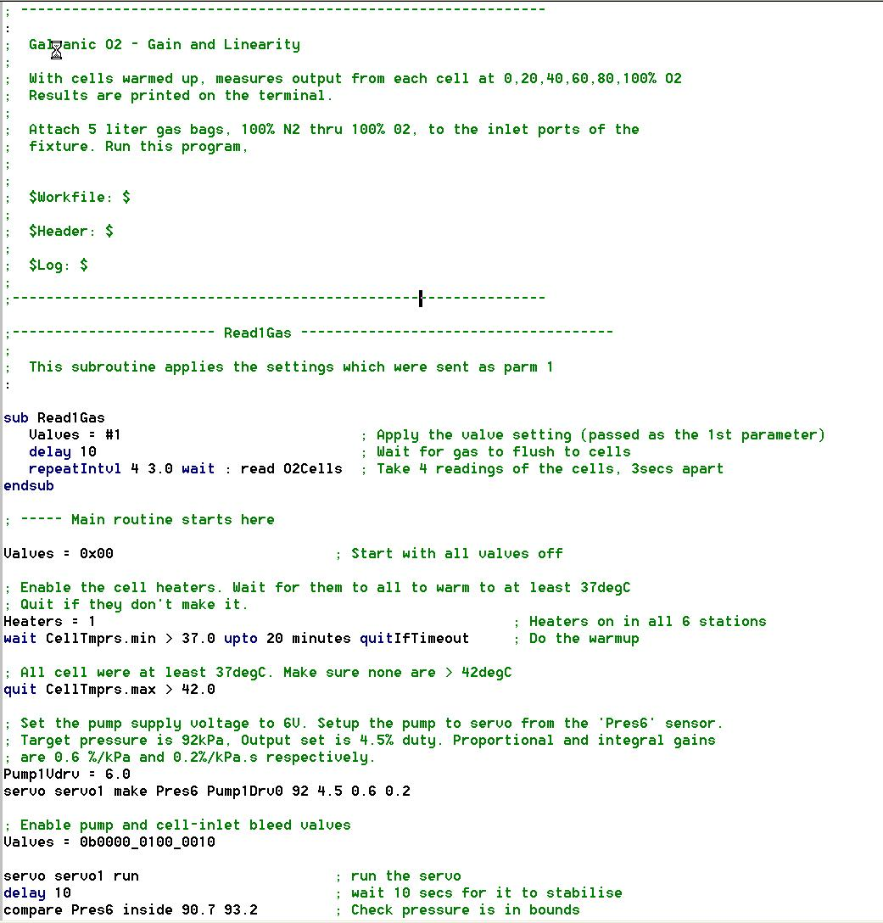
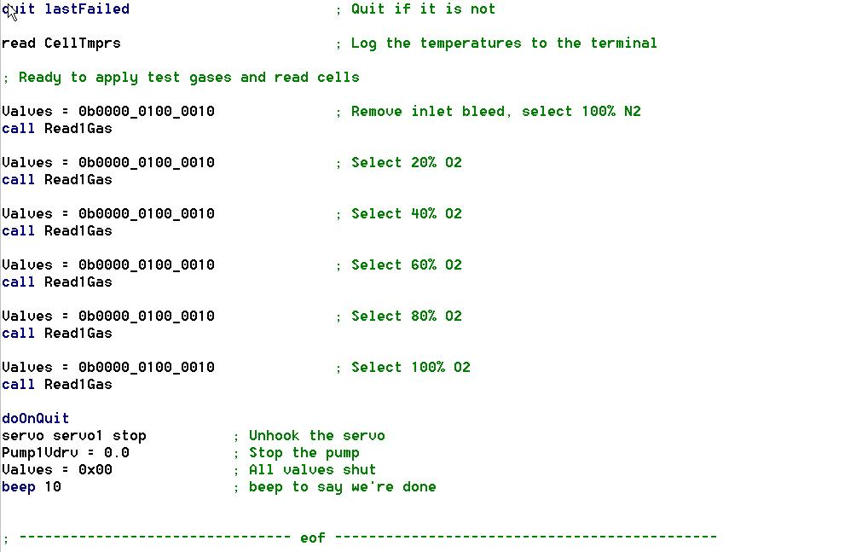

End of File

